 SRM Institute of Science and Technology
Ramapuram campus
Department of Mathematics
18MAB101T – Calculus and linear algebra

Year/Sem: I/I Part-A Branch: Common to All
Unit – IV
Differential Calculus

1. | The locus of centre of curvature is called | 1 Mark
1. | (a) Involute (b) Evolute  (c) Radius of curvature (d) Envelope | Ans (b) | (CLO-4  Remember)
2. | The envelope of the family of curves Aα²+Bα+C = 0 ( α is parameter) is | 1 Mark
 | - B² + 4AC = 0 (b) B² – 4AC = 0  - B² + AC = 0 (d) B² – AC = 0 | Ans (b) | (CLO-4  Remember)
3. | The curvature of the straight line is | 1 Mark
 | (a) 1 (b) 2  (c) -1 (d) 0 | Ans (d) | (CLO-4  Remember)
4. | Evolute of a curve is _____ of the normals of that curve | 1 Mark
 | (a) Involute (b) Length  (c) Envelope (d) End points | Ans (c) | (CLO-4  Remember)
5 | The radius of curvature at (3,4) on the curve x² + y² = 25 is | 1 Mark
 | (a) 5 (b) 4  (c) 0 (d) 2 | Ans (a) | (CLO-4  Remember)
6. | What is the curvature of a circle of radius 3? | 1 Mark
 | (a) 3 (b) – 3  (c) (d) 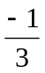 | Ans (c) | (CLO-4  Remember)
7. | In an ellipse 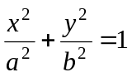the radius of curvature at the end of which axis is equal to the semi-latus rectum? | 1 Mark
 | (a) minor (b) major  (c) vertical (d) horizontal | Ans (b) | (CLO-4  Remember)
8. | Evolute of a curve is the envelope of _____ of that curve. | 1 Mark
 | (a) tangent (b) normal  (c) parallel (d) locus | Ans (b) | (CLO-4  Remember)
9. | The evolute of the cycloid x = a (θ − sin θ) , y = a (1 − cos θ) is | 1 Mark
 | (a) astroid (b) parabola  (c) cycloid (d) circle | Ans (c) | (CLO-4  Remember)
10. | A curve which touches each member of a family of the curves is called − − − of that family | 1 Mark
 | (a) Evolute (b) Envelope  (c) Circle of curvature (d) Radius of  curvature | Ans (b) | (CLO-4  Remember)
11. | Envelope of the curve y = mx + 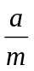 (where m is the parameter) is | 1 Mark
 | (a) x² + ay = 0 (b) x + 4ay = 0  (c) y² – 4ax = 0 (d) y² + 4ax = 0 | Ans (c) | (CLO-4  Remember)
12. | If the radius of curvature and curvature of a curve at any point are ρ and k respectively, then | 1 Mark
 | (a) 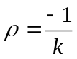 (b) 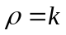  (c) 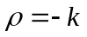 (d) 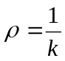 | Ans (d) | (CLO-4  Remember)
13 | The radius of curvature at the point (0, c) of the curve y = c cosh 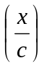 is | 1 Mark
13 | (a) 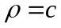 (b) 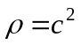  (c) 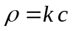 (d) 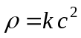 | Ans (a) | (CLO-4  Remember)
14 | The radius of curvature of the curve y = e^{x} at x=0 is | 1 Mark
 | (a) 2 (b)  (c) 2 (d) 4 | Ans (a) | (CLO-4  Remember)
15 | The radius of curvature at the point (x, y) of the curve y = c log sec is | 1 Mark
15 | (a) 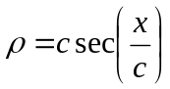 (b) 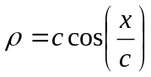  (c) 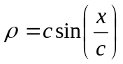 (d) 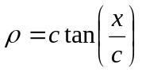 | Ans (a) | (CLO-4  Remember)
16 | The parametric form of the curve y² = 4ax is | 1 Mark
16 | (a) x = at²; y = 2at (b) x = at; y = 2at  (c) x = at²; y = 2at² (d) x = 2at²; y = 2at | Ans (a) | (CLO-4  Remember)
17 | The envelope of the curve y = mx + where m is the parameter is | 1 Mark
17 | (a) y² – 4ax = 0 (b) y² + 4ax = 0  (c) x² + y² = 1 (d) xy = c² | Ans (a) | (CLO-4  Remember)
18 | The radius of curvature of the curve y = log sec x at any point on it is | 1 Mark
18 | (a) sec x (b) tan x  (c) cot x (d) cosec x | Ans (a) | (CLO-4  Remember)
19 | The radius of curvature of the curve x = t ² , y = t at t = 1 is | 1 Mark
19 | (a) 5 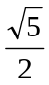 (b)  (c)  (d)  | Ans (a) | (CLO-4  Remember)
20 | The radius of curvature of the parabola y² = 12x at (3, 6) is | 1 Mark
20 | (a) 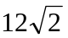 (b) 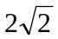  (c) 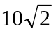 (d) | Ans (a) | (CLO-4  Remember)
21 | The radius of curvature of the curve y = 4 sin x at x =  is | 1 Mark
21 | (a)  (b) 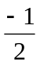  (c)  (d) 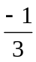 | Ans (c) | (CLO-4  Remember)
22 | The envelope of family of lines y = m x + a m² (where m is the parameter) is | 1 Mark
22 | (a) x² + 2ay = 0 (b) x² + 4ay = 0  (c) y² + 2ax =0 (d) x² + 4ax = 0 | Ans (b) | (CLO-4  Remember)
23 | The envelope of the family of lines 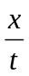 + yt = 2c, t being the parameter is | 1 Mark
23 | (a) x² + y² = c² (b) xy = c²  (c) x² y² = c² (d) x² – y² = c² | Ans (b) | (CLO-4  Remember)
24 | The radius of curvature at any point on the curve r = e^{θ} is | 1 Mark
24 | (a) 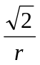 (b) 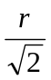  (c) r (d) r | Ans (d) | (CLO-4  Remember)
25 | The radius of curvature in Cartesian coordinates is | 1 Mark
25 | (a) 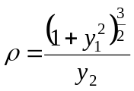 (b) 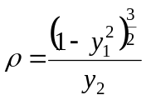  (c) 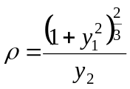 (d) 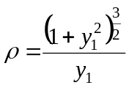 | Ans (a) | (CLO-4  Remember)
26 | The envelope of ty − x = at² , t is the parameter is | 1 Mark
26 | (a) x² = 4ay (b) y² = 4ax  (c) x² + y² = 1 (d) x² – y² = 1 | Ans (b) | (CLO-4  Remember)
27 | The radius of curvature in polar coordinates is | 1 Mark
27 | (a) 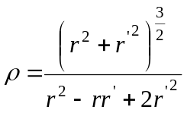 (b)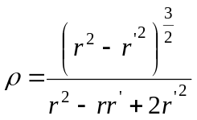 (c) 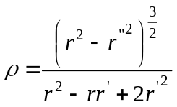 (d) 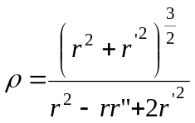 | Ans (d) | (CLO-4  Remember)
28 | The radius of curvature in parametric coordinates is | 1 Mark
28 | (a) 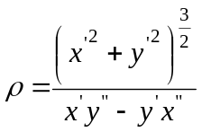 (b) 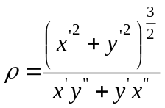  (c) 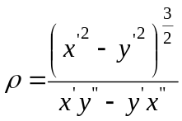 (d) 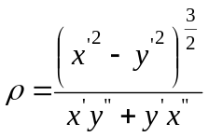 | Ans (a) | (CLO-4  Remember)
29 | The equation of circle of curvature at any point (x, y) with center of curvature 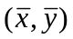 and radius of curvature ρ is | 1 Mark
29 | (a) 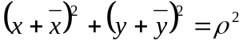 (b) 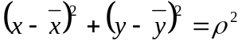  (c) 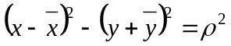 (d) | Ans (b) | (CLO-4  Remember)
30 | The curvature at any point of the circle is equal to___ of its radius | 1 Mark
 | (a) same (b) ellipse  (c) reciprocal (d) constant | Ans (c) | (CLO-4  Remember)
31 | The parametric equations of rectangular hyperbola xy = c² is | 1 Mark
 | (a) 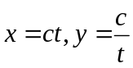 (b) 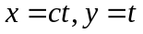  (c) 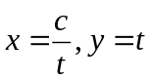 (d) 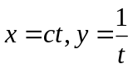 | Ans (a) | (CLO-4  Remember)
32 | The value of 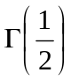 is | 1 Mark
 | (a) (b)  (c) 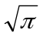 (d) 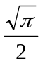 | Ans (c) | (CLO-4  Remember)
33 | The series 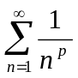 is convergent if | 1 Mark
 | (a) p = 0 (b) p =1  (c) p > 1 (d) p < 1 | Ans (c) | (CLO-4  Remember)
34 | As per D’ Alembert’s ratio test, if 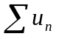 is a series of positive terms and 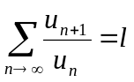, then the series is convergent, if | 1 Mark
 | (a) = 0 (b) =1  (c) > 1 (d) < 1 | Ans (d) | (CLO-4  Remember)
35 | If n is a positive integer, then 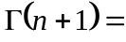 | - Mark
 | (a) (n + 1)! (b) n!  (c) 2n! (d) (n – 1)! | Ans (b) | (CLO-4  Remember)
36 | The series 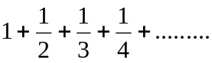 is | 1 Mark
 | (a) convergent (b) divergent  (c) oscillating (d) monotonic | Ans (b) | (CLO-4  Remember

